**ACPS PROJECT (2024-25)**

**Campus Network Design Using Cisco Packet Tracer and performing**

**Network Attacks**

**MID-TERM REPORT**



**IIITDM JABALPUR**

# Submitted by-

Shubham kumar (22bsm056) Ankit Gopi (22bsm019) Aryan (22bsm00010) Ayush anand (22bsm011) Dristi kushwaha(22bsm018)

***Supervised By: -***

## DR Sachin kumar saxena Department of Mechinical engneering

**Table Of Content**

|  |  |  |
| --- | --- | --- |
| 1. | Abstract | 3 |
| 2. | Introduction & Problem Statement | 4 |
| 3. | Theory | 5 |
| 4. | Software And Hardware Requirement | 9 |
| 5. | Basic Layout, Implementation and Flow Diagram | 10 |
| 6. | Configuring IP Address | 13 |
| 7. | Wireless Access Points & Security | 20 |
| 8. | Progress till date & Remaining Work | 21 |
| 9. | Conclusions and Future Work | 22 |
| 10. | References | 23 |

# ABSTRACT

Computer networks have a significant impact on the working of an organization. Universities depend on the proper functioning and analysis of their networks for education, administration, communication, e-library, automation, etc. An efficient network is essential to facilitate the systematic and cost-efficient transfer of information in an organization in the form of messages, files, and resources. The project provides insights into various concepts such as topology design, IP address configuration, and how to send information in the form of packets to the wireless networks of different areas of a University.

The aim of this project is to design the topology of the university network using the software Cisco Packet Tracer with the implementation of wireless networking systems. This university network consists of the following devices:

1. Router (1941)
2. Switches (2960-24TT)
3. Email server
4. DNS server
5. WEB server (HTTP)
6. Wireless Device (Access Point)
7. PCs
8. Laptops
9. Smartphones

The design includes the following parts of the University:

**Hostel Blocks Admin Blocks**

**Others Building and Library**

# INTRODUCTION

Campus networking via wireless connection becomes an important part of campus life and provides the main way for teachers and students to access educational resources, which gives

an important platform to exchange information. As laptops and intelligent terminals are widely used, demand for access to information anytime and anywhere has become more and more urgent, but traditional cable networks cannot meet this requirement. Then wireless network construction becomes necessary and essential. The wireless network is one of the important components of a digital campus and wisdom campus. It provides an efficient way

to explore the internet with a mobile terminal for teachers and students regardless of cables

and places. This is an important mark of the modern campus as a supplement of a cable network. With the development of network and communication technology, cable networks

on a university campus bring much convenience for teaching and research work. But for mobility and flexibility, it has obvious shortcomings. A wireless network can overcome these drawbacks and has been applied to the university campus.

### Project Statement

In this Acps project , we defined a simulation of campus networks based on wireless networking. The network is divided into two sets: one for the campus area and the other for the hostel area.

The major aim of this project is to show the wireless connectivity that is used in universities to make the network efficient and mobile at the same time. Mobility is the major concentration of this project. In order to provide equal functionality to all the users (college staff and students), we have added DNS, Email, and HTTP servers for the maximum utilization of resources.

Hence the campus network provides different services such as connecting the user to the internet, data sharing among users (students, teachers, and different university members), accessing different web services for different functionalities, so it needs wireless networking

for smooth processing.

# THEORY

### What is Packet Tracer?

Packet Tracer is a cross-platform visual simulation tool designed by Cisco Systems that allows users to create network topologies and imitate modern computer networks. The software allows users to simulate the configuration of Cisco routers and switches using a simulated command-line interface. Packet Tracer makes use of a drag-and-drop user interface, allowing users to add and remove simulated network devices as they see fit. The software is mainly focused on Certified Cisco Network Associate Academy students as an educational tool for helping them learn fundamental CCNA concepts. Previously students enrolled in a CCNA Academy program could freely download and use the tool free of charge

for educational use.

### Router

A router is a device like a switch that routes data packets based on their IP addresses. The router is mainly a Network Layer device. Routers normally connect LANs and WANs together and have a dynamically updating routing table based on which they make decisions on routing the data packets. Router divides broadcast domains of hosts connected through it.

### Switch

A network switch (also called switching hub, bridging hub, officially MAC bridge is networking hardware that connects devices on a computer network by using packet switching to receive and forward data to the destination device. A network switch is a multiport network bridge that uses MAC addresses to forward data at the data link layer (layer 2) of the OSI model. Some switches can also forward data at the network layer (layer 3) by additionally incorporating routing functionality. Such switches are commonly known as layer-3 switches or multilayer switches.

### Network Packet

A network packet is a formatted unit of data carried by a packet-switched network. A packet consists of control information and user data, which is also known as the payload.

### Wireless Network

A wireless network broadcasts an access signal to the workstations or PCs. This enables mobility among laptops, tablets, and PCs from room to room while maintaining a firm network connection continuously. A wireless network also presents additional security requirements.

### Server

A server is a computer or system that provides resources, data, services, or programs to other computers, known as clients, over a network. In theory, whenever computers share resources with client machines they are considered servers. There are many types of servers, including web servers, mail servers, and virtual servers.

Many networks contain one or more of the common servers. The servers used in our project are as follows:

### DNS Server

DNS stands for Domain Name System servers which are application servers that provide a human-friendly naming method to the user computers in order to make IP addresses readable by users. The DNS system is a widely distributed database of names and other DNS servers, each of which can be used to request an otherwise unknown computer name. When a user needs the address of a system, it sends a DNS

request with the name of the desired resource to a DNS server. The DNS server responds with the necessary IP address from its table of names.

### WEB Server

One of the widely used servers in today’s market is a web server. A web server is a special kind of application server that hosts programs and data requested by users across the Internet or an intranet. Web servers respond to requests from browsers running on client computers for web pages, or other web-based services.

### EMAIL Server

An e-mail server is a server that handles and delivers e-mail over a network, using standard email protocols. For example, the SMTP protocol sends messages and handles outgoing mail requests. The POP3 protocol receives messages and is used to process incoming mail. When you log on to a mail server using a webmail interface or email client, these protocols handle all the connections behind the scenes.

### Ethernet

This is the backbone of our network. It consists of the cabling and is typically able to

Transfer data at a rate of 100mb/s. It is a system for connecting a number of computer systems to form a local area network, with protocols to control the passing of information and

to avoid simultaneous transmission by two or more systems. Among the different types of ethernet, we have used Gigabit Ethernet, which is a type of Ethernet network capable of transferring data at a rate of 1000 Mbps and fast Ethernet is a type of Ethernet network that

can transfer data at a rate of 100 Mbps.

### Computing Device

Computing devices are the electronic devices that take user inputs, process the inputs, and then provide us with the end results. These devices may be Smartphones, PC Desktops, Laptops, printer, and many more.

### Internet Protocol

Internet Protocol (IP) is one of the fundamental protocols that allow the internet to work. IP addresses are a unique set of numbers on each network and they allow machines to address each other across a network. It is implemented on the internet layer in the IP/TCP model.

### SSH Protocol

Secure Shell enables a user to access a remote device and manage it remotely. However, with SSH, all data transmitted over a network (including usernames and passwords) is encrypted and secure from eavesdropping.

SSH is a client-server protocol, with an SSH client and an SSH server. The client machine (such as a PC) establishes a connection to an SSH server running on a remote device (such as a router). Once the connection has been established, a network admin can execute commands on the remote device.

### Simulation Environment

The simulations of our network topology can be easily achieved using cisco packet tracer. Using a simulation mode, you can see packets flowing from one node to another and can also click on a packet to see detailed information about the OSI layers of the networking. Packet Tracer offers a huge platform to combine realistic simulation and visualize them simultaneously. Cisco Packet Tracer makes learning and teaching significantly easier by supporting multi-user collaboration and by providing a realistic simulation environment for experimenting with projects.

# WORK DONE

In order to make our project understandable, we have divided the content into steps. They are as follows:

### Software and hardware requirements

Before heading towards the implementation we need to make sure of the following requirements.

* + - A proper workstation (any mid-high range laptop will suffice).
    - Packet Tracer by Cisco
    - 8 GB RAM.
    - Any 10,000+ Average CPU Mark scored processor.
    - 16 GB of dedicated hard disk space.
    - USB 3.0+ port.

### Network Requirements

GLA University Mathura outline is considered for this wireless university network. The network is divided into 2 areas :

## Acadmic Area

The Campus area is further divided into various accessing points like LHTC building, Library, Academic Blocks ,, Server Center, and

CLC.

## Hostel Area

The Hostel area is further divided into Boys blocks and Girls blocks respectively.

### Layout

Figure – Basic Layout of our wireless access points in University

Devices Used In The Network

|  |  |
| --- | --- |
| Devices | Quantity |
| 1) Router (1941,819 HG) | 4 |
| 2) Switches (2960-24TT,3650) | 52 |
| 3) EMAIL server | 1 |
| 4) DNS server | 1 |
| 5) WEB server (HTTP) | 1 |
|  |  |
| 7) PCs | 16 |
| 8) Laptops | 16 |
| 9) Printers | 16 |

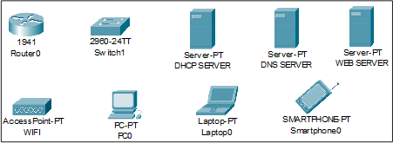

Figure 3: Devices used in the network

### Implementation and Flow Diagram

* + To design the wireless network of the university we initially started by placing the core devices into the frame as mentioned in the layout.
  + Firstly, we placed the **main router** at the center of the university outline, which was further connected to the **server switch** using the gigabit ethernet port with copper straight-through cable and sub routers (Acadmics **router and hostel router**) using the serial port with serial DCE cable at the hostel area and campus area respectively.
  + The server switch was further connected to the **EMAIL, DNS, and WEB**

servers respectively.

* + Campus router was connected to the campus switch which was further connected with wireless access points of the academic block

**LHTC building**, **library,** and CLC**.**

* + The wireless access points were then connected to computing devices (PCs, laptops, and Printers).
  + Similarly, the hostel router was connected to the hostel switch which was further connected with the wireless access point of boys block and girls block.
  + The wireless access points were then connected to the computing devices (PCs, laptops, and smartphones), every area has a dedicated access point which can only be connected with the help of a password.
  + All these connections are made through ethernet ports (gigabit ethernet and fast ethernet) using copper straight-through cables.

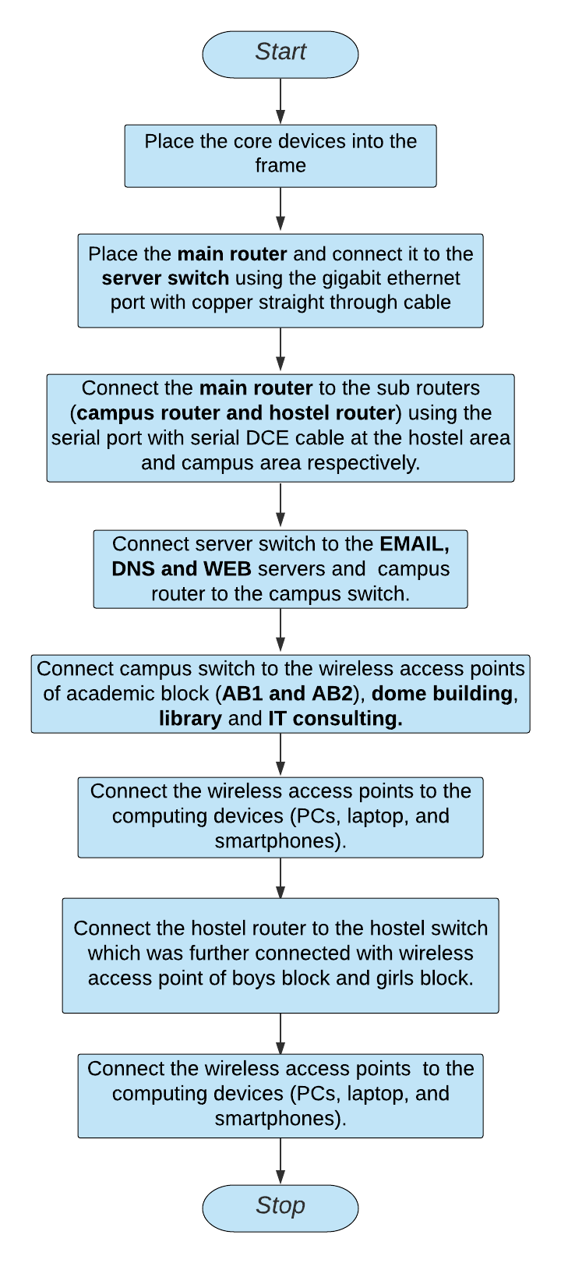

This is the flow diagram for a better understanding of the steps mentioned above.

### Configuring IP Addresses

We have attached the screenshots of all the IP configuration below:

* + Main Router configuration

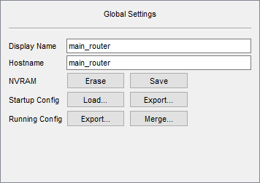

GigabitEthernet0/1

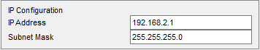

Serial0/1/0

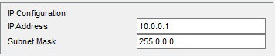

Serial0/1/1

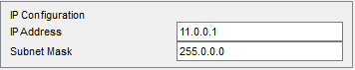

RIP

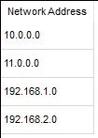

* **DNS SERVER**

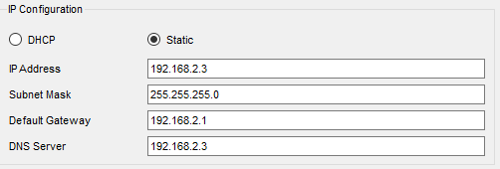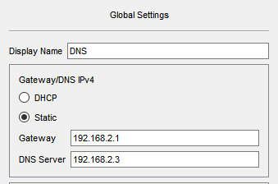

* **WEB SERVER**

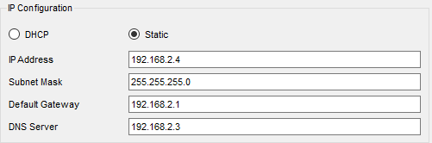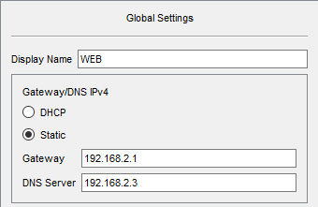

* **EMAIL SERVER**

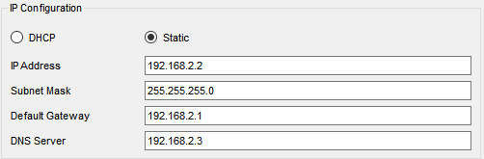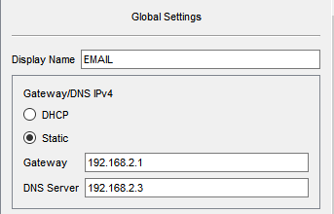

* **COLLEGE ROUTER**

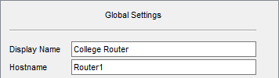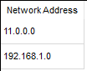

GigabitEthernet0/0

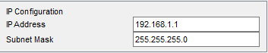

Serial0/1/0

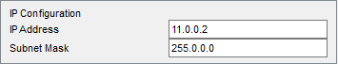

### Admin block(DSA)

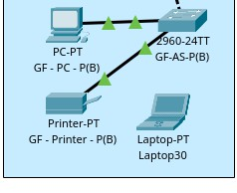

IP Address are as follows 192.168.1.14- Laptop

192.168.1.15- PC

192.168.1.16 Printer

Subnet Mask- 255.255.255.0

Default Gateway- 192.168.1.1

DNS Server- 192.168.2.3

Admin Block (DSA)

* 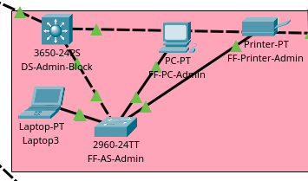​

IP Address are as follows 192.168.1.10- Laptop

192.168.1.11- PC

192.168.1.12- Printer

Subnet Mask- 255.255.255.0

Default Gateway- 192.168.1.1

DNS Server- 192.168.2.3

### LHTC BUILDING

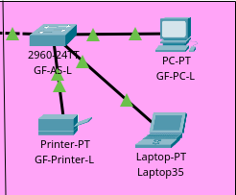

IP Addresses are as follows 192.168.1.2- PC

192.168.1.3- Printer

192.168.1.4- Laptop

Subnet Mask- 255.255.255.0

Default Gateway- 192.168.1.1

DNS Server- 192.168.2.3

### LIBRARY

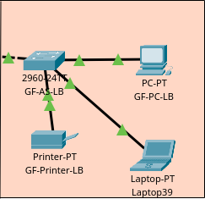

IP Addresses are as follows 192.168.1.5- PC

192.168.1.6- Printer

Subnet Mask- 255.255.255.0

Default Gateway- 192.168.1.1

DNS Server- 192.168.2.3 Laptop:192.168.1.7

* CLC



IP Addresses are as follows 192.168.1.7- Laptop

192.168.1.8- PC

192.168.1.9- Printer

Subnet Mask- 255.255.255.0

Default Gateway- 192.168.1.1

DNS Server- 192.168.2.3

### HOSTEL ROUTER

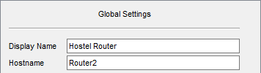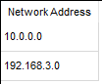

GigabitEthernet0/0

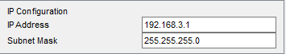

Serial0/1/0

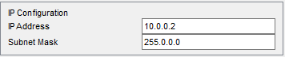

### Boys Block

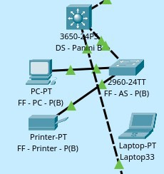

IP Addresses are as follows 192.168.3.6- PC

192.168.3.7-Laptop

192.168.3.8- Printer

Subnet Mask- 255.255.255.0

Default Gateway- 192.168.3.1

DNS Server- 192.168.2.3

### Girls Block

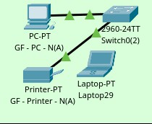

IP Addresses are as follows 192.168.3.2- PC

192.168.3.3-Laptop

192.168.3.4- Printer

Subnet Mask- 255.255.255.0

Default Gateway- 192.168.3.1

DNS Server- 192.168.2.3

* **WIRELESS ACCESS POINT**

|  |  |
| --- | --- |
| SSID | Password |
| 1)muj_lhtc | 1234567890 |
| 2)muj_library | 1234567890 |
| 3)muj_clc | 1234567890 |
| 4)muj_dsa | 1234567890 |
| 5)muj_hostel | 1234567890 |
| 6)muj_boys | 1234567890 |
| 7)muj_girls | 1234567890 |

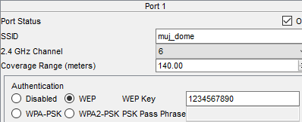

## Securing the network

Passwords are used in accessing the router and all the wireless networks (mentioned

in step 5 wireless access point) to make the access limited to University authorized users only.

Routers are also secured with ssh (Secure Shell). Routers and their assigned passwords are mentioned below:

|  |  |
| --- | --- |
| Router Name | Passwords |
| 1)main_router | Console password: cisco ssh password: admin |
| 2)Router1(College Router) | Console password:muj@123 ssh password: admin |
| 3)Router2(Hostel Router) | Console password:muj@123 ssh password: admin |

# Progress [80%]

**Completed Parts of Project**

1. Networking Layout is created.
2. Configuration of Networking devices and IP Address is done.
3. Wireless Access points and Security is also done.

## Remaining parts of Project

1. Some Connection are left of Academic block and Hostels Network.
2. Some Connection Of DNS and WEB Servers are left.
3. Ping Test and Simulation Test are Left

# CONCLUSION AND FUTURE WORK

### Conclusion

We started our discussion with the word “Industry 4.0” and in order to achieve it, we aimed to start with an educational institute, and finally, we designed a network for a Our campus IIITDMJ, As we mentioned, Robust and Secure Network are the key aspects of industry 4.0 , which were our main goal, and hence, we decided to

Extend our work in network security instead of a just networking, it will make our network Secure and reliable

In this project, we designed a University Network using Cisco Packet Tracer that uses a networking topology implemented using servers, routers, switches, and end devices in a multiple area networks. We have covered all the necessary features that are required for a network to function properly. We have included a DNS server and a web server for establishing a smooth communication system between different areas of our network and specifically for the communication between students and teachers. We have included an email server to facilitate intra university communication through emails within the domain. We have used console passwords and ssh protocol to ensure a safe and secure transfer of data.

* ​

Future work

Project Objective: Simulating a brute force attack on network services to demonstrate potential vulnerabilities

in login systems like FTP or Telnet.

Tools Used: Cisco Packet Tracer for network simulation and Kali Linux for brute force attack execution using tools like Hydra or Medusa.

Network Topology: A simple network setup with a router, switch, and two PCs, representing the attacker and the victim server.

IP Configuration: Each device in the network is assigned static IP addresses within the same subnet to ensure proper communication.

Services Configuration: The victim server (PC1) is configured to run FTP or HTTP services with login credentials.

Attack Simulation: Brute force attack simulated using repeated login attempts on the victim server from the attacker machine.

Authentication Target: Target services for brute force attacks include FTP login and potentially HTTP if expanded.

Testing Automation: Hydra or Medusa tools used in Kali Linux to automate multiple login attempts against the server’s FTP service.

Packet Tracer Simulation: Network traffic monitored using Packet Tracer’s Simulation Mode to observe login attempts and responses.

Security Insights: Demonstration of the importance of strong passwords and rate limiting to prevent brute force attacks in real-world scenarios.